Detailed Software Technical Design (DSTD)
For
VShare Securities

Table of Contents

1 Introduction 5
1.1 Purpose 5
1.2 Scope 5
1.3 Definitions, Acronyms and Abbreviations 5
1.4 References 5
2 Assumptions 6
3 PROJECT OVERVIEW AND USECASE DIAGRAMS 6
4 Detailed Design for Module: <<Module Name>> 7
4.1 Detailed Design for Feature: <<Feature Name>> 7
4.1.1 User Profile 7
4.1.2 Navigation Map 7
4.1.3 UI Screen Design 7
4.1.3.1 Screen Layout 7
4.1.3.2 Validations 8
4.1.4 Object Model/Data Flow Design 8
4.1.4.1 Interface Description 8
4.1.4.2 Class Design 8
4.1.4.2.1 Algorithmic/Business Logic Description (Optional) 8
4.1.4.2.2 Local Data Structure (Optional) 8
4.1.4.3 Data Transfer/Value objects 8
4.1.4.4 Related Database Tables 9
4.1.4.5 Dependencies with Other Sub-systems/Components 9
4.2 Detailed Design for Feature: <<Feature Name>> 9
5 Detailed Design for Module: <<Module Name>> 10
6 Database Design 11
6.1 Entity Relationship Diagrams 11
7 Packaging/Folder Structure and System Artifacts 12
7.1 System Artifacts 12
8 Core Technical Services Design 13
8.1 Persistence 13
8.2 Inter-process Communication 13
8.3 Authentication and Authorization 13
8.4 Error Handling 13
8.5 Logging 13
8.6 Transaction Management 13
8.7 Other Applicable Technical Services 13
9 Non Functional Requirements 14
Appendix 14
1. Design Metrics to be Used 14
2. Supplementary Information 14
3. DQI – Design Quality Index Checklist 14

Document Revisions

Date | Version | Description | Author | Reviewer | Approver

Information Handling

These documents are strictly for Virtusa/Client use only. They shall not be shared with an external party other than the client concerned. These documents should always be kept securely and employees shall use reasonable care protecting these documents from unauthorized use or disclosure to a third party. This category also covers client intellectual property where Virtusa has a non-disclosure agreement with the client.

Introduction

Purpose

This document provides the detailed technical design for the VShare Securities
and Online Stock Market system..

Scope

VShare Securities is a leading share brokers in India. We are planning to re-engineer our Trading Platform and web application since it is currently lacking rich UI features and suffering due to heavy load issues.

Our top priority in this re-engineering effort is the performance and user experience. We are planning to launch a new stock broking mobile app as part of this re-engineering effort. In addition to this, we need to add a good recommendation engine to both web and mobile apps to improve our customer base with an enriched customer experience.

Definitions, Acronyms and Abbreviations

AngularJS:

AngularJS is a JavaScript-based open-source front-end web framework mainly maintained by Google and by a community of individuals and corporations to address many of the challenges encountered in developing single-page applications.

Spring Boot :

Spring Boot is an open source Java-based framework used to create a micro Service. It is developed by Pivotal Team and is used to build stand-alone and production ready spring applications.

MySQL:

MySQL is a relational database management system based on SQL – Structured Query Language. The application is used for a wide range of purposes, including data warehousing, e-commerce, and logging applications. The most common use for mySQL however, is for the purpose of a web database.

References

[This sub-section must provide a complete list of all references. Identify each document by title, document number and the version. Specify the sources from which the references can be obtained.

Assumptions

[List the assumptions, if any, here.]

PROJECT OVERVIEW AND USECASE DIAGRAMS

Application to include the below modules as a basic ones and additionally, value adds inclusions will be appreciated.
- Trading Platform to buy and sell
- Brokerage Charges Calculation
- Payments with Payment Gateway
- Customer Management
- Research & Recommendations
- Watch List
- Forum that includes Customer reviews
- Search Stocks, Stock Ratings and Charts to represent their past records
- Reporting
- Data Management for the above modules.
- Watch List
- Notification triggers to agent and customers

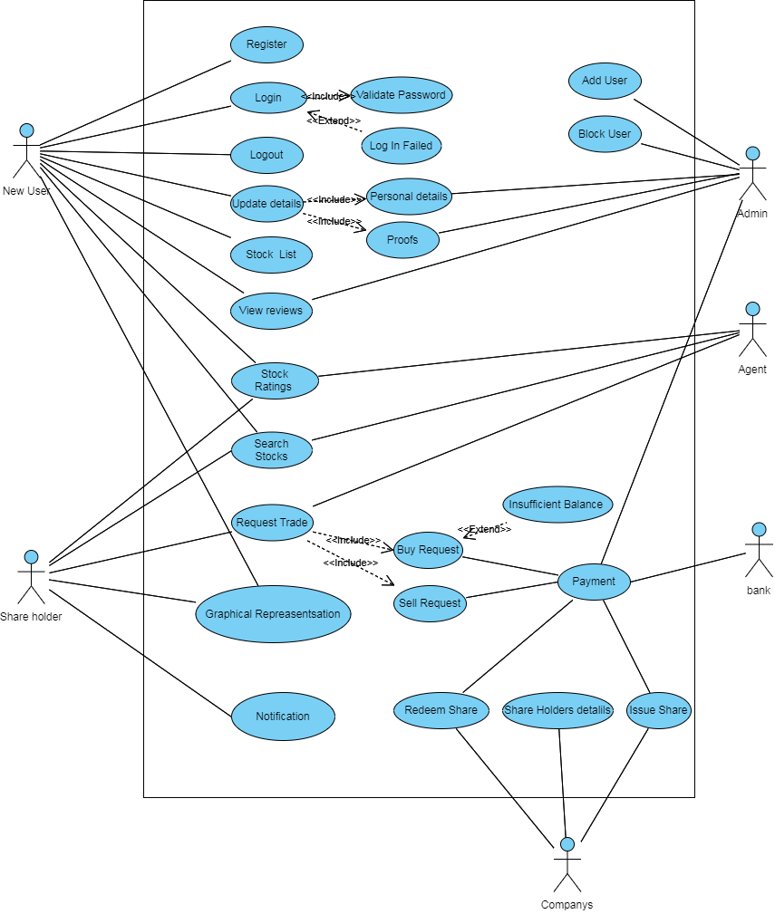

Detailed Design for Module: V Share
This section describes the detailed design for the V Share module.

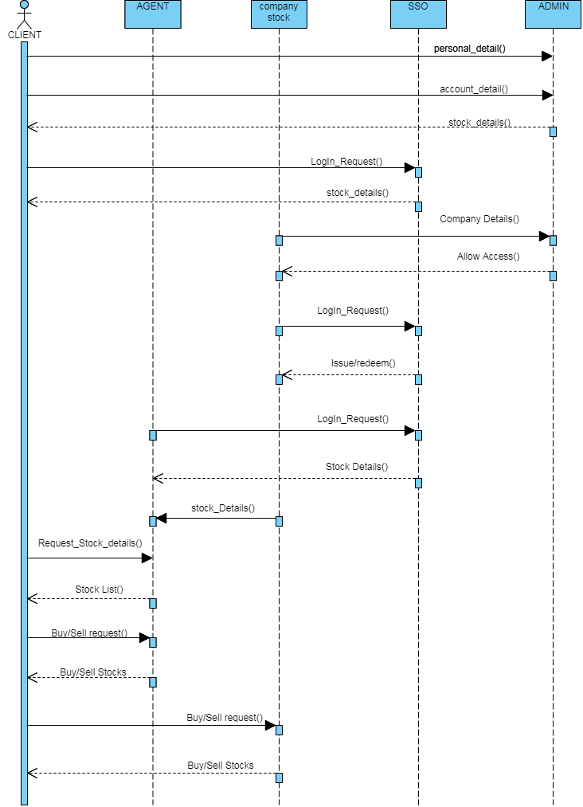
User Profile

[Describe the different user types with the security profiles and specify the roles that can access these screens.]

Navigation Map

[Describe the navigation map along with use case traceability of all screens for this feature.]

UI Screen Design

Page Summary
Name | Search for Customer File
Description | The user retrieves the customer information based on the search criteria such as File ID, last name, first name, middle name, business name, SSN/TIN, address, city, state and/or zip.
Use Case Number | UC-002

Screen Layout

Validations

Error Trigger | Action | Description
If the user group is not selected. | Displays the message “Please select a User Group from the list”. | Prompts the user to select an entry from the User Group list.
User enters an invalid date | Displays the message “Enter a valid date. The date must be in <mm-dd-yyyy> format”. | Displays invalid date message.

Object Model/Data Flow Design

[This sub-section describes the detailed design for the system pertaining to the <<Feature Name>> feature. Interaction diagrams showing the details of the component structure, behavior, or information/control flow may be included in the sub-section devoted to that particular component.]

Interface Description

[Describe the interfaces including component interfaces and interfaces to other systems, products, or networks.]

Class Design
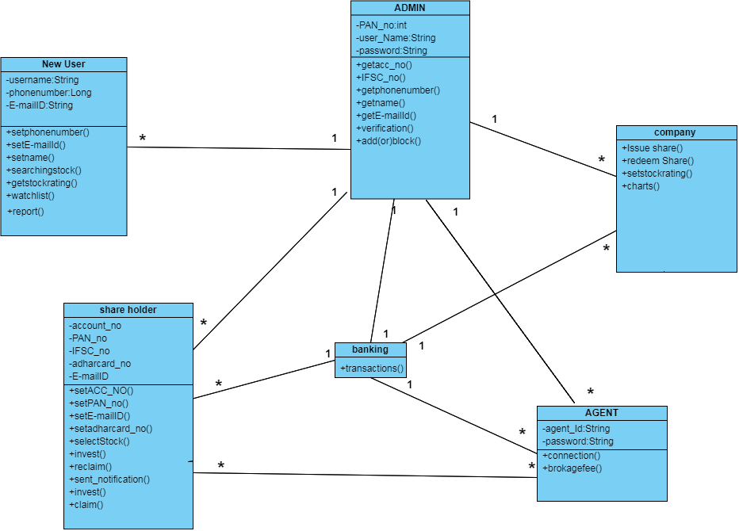

Algorithmic/Business Logic Description (Optional)

[Describe complex algorithms used in the class (if any).]

Local Data Structure (Optional)

[Describe key data structure algorithms used (if any).]

Data Transfer/Value objects

[Based on the design pattern being used, identify and describe the value/transfer objects.]

Related Database Tables

[Give the list of related database tables.]

Dependencies with Other Sub-systems/Components

[Describe the dependencies with other sub-system/components, if any.]

Detailed Design for Feature: <<Feature Name>>

Repeat all sub-sections given in 3.1 for this feature.

Detailed Design for Module: <<Module Name>>

[Detailed design for Module 2.]

Repeat all sub-sections given in section 3 for this module.

Database Design

[This section describes the persistent data and metadata used and generated by the module/sub-system. This will include database schemas (if the database schema is large, use a separate document for database design), registry structures, property file structures, etc.

Models | Tools
Database Entity Relationship Diagrams | ERWin
Object Models | Rational Rose

Entity Relationship Diagrams

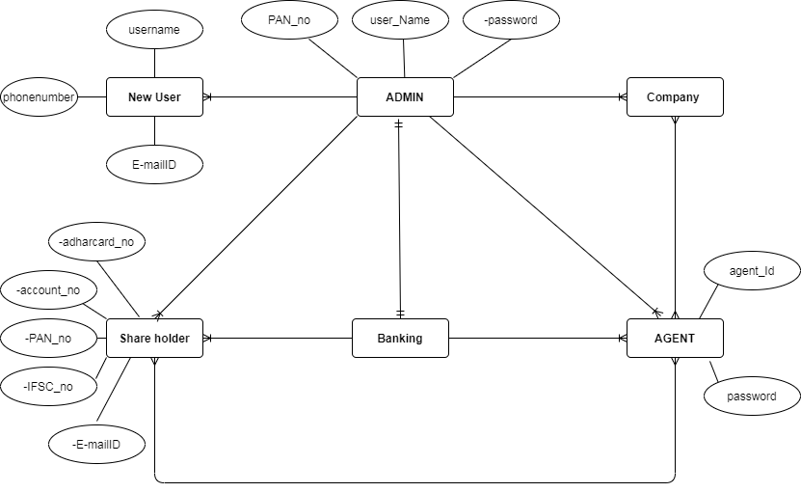

State Diagram:

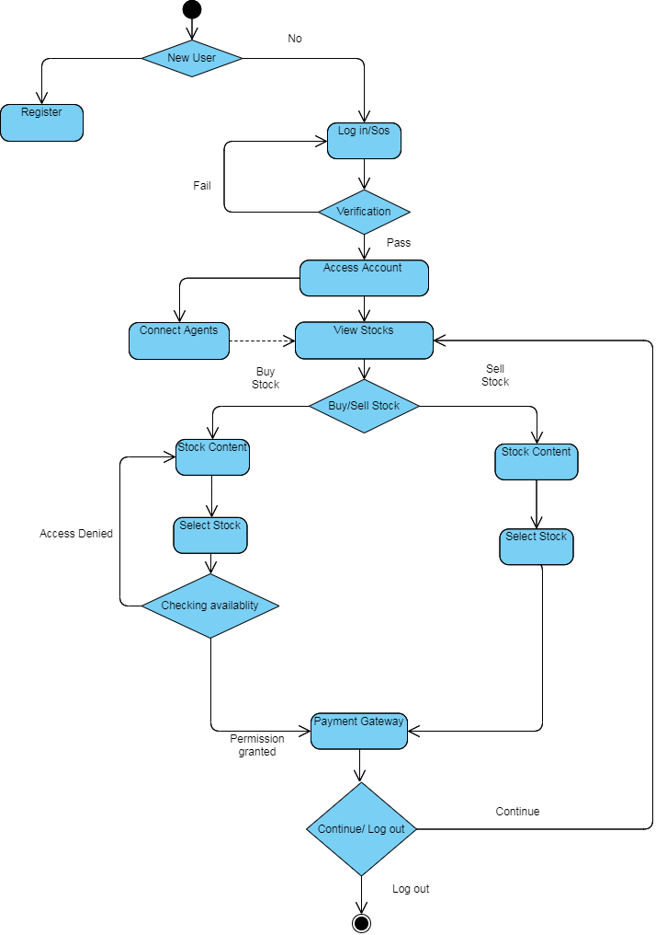

Package Diagram:
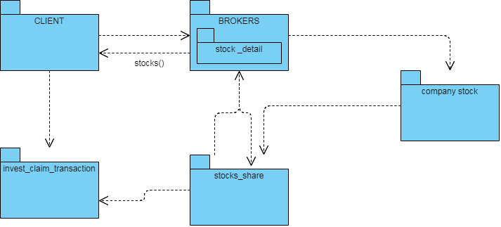

Packaging/Folder Structure and System Artifacts

[This section describes the file structure for the <Project Name> project, which will indicate where the code, unit tests, executables, libraries, etc. are to be placed during implementation. Optionally the file structure can be described in a separate GA chapter and a reference given here.]

[Sample structure

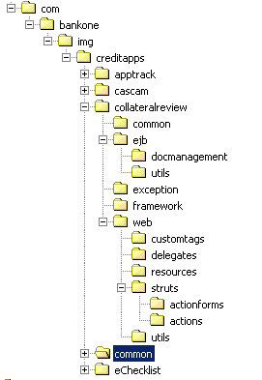
End Sample Structure]

System Artifacts

[Provide information on the Registry structure, INI files, property files, configuration files, etc.]

Core Technical Services Design

[This section describes the detailed design and usage pattern for the core technical services of the system.]

Persistence

[This sub-section captures the detailed design and usage patterns of the persistence service for the application.]

Inter-process Communication

[This sub-section captures the detailed design and usage patterns of the inter-process communication framework for the application.]

Authentication and Authorization

[This sub-section captures the detailed design and usage patterns of the security services for the application.]

Error Handling

This sub-section captures the detailed design and usage patterns of the error handling services for the application.]

Logging

[This sub-section captures the detailed design and usage patterns of the logging framework for the application.]

Transaction Management

[This sub-section captures the detailed design and usage patterns of the Transaction Management service for the application.]

Other Applicable Technical Services

[This sub-section captures the detailed design and usage patterns of the other core technical services to be handled by the system such as the installation mechanism, failure prevention, fault tolerance, caching design, internationalization, validation framework, client and server initialization, error handling, etc.]

9 Non Functional Requirements

Appendix

[Presents information that supplements the design specification.]

Design Metrics to be Used

[A description of all design metrics to be used during the design activity is listed here.]

Supplementary Information

[Provide as required.]

DQI – Design Quality Index Checklist
This checklist shall be used to perform self-review as a reference while preparing software design.
